**Understand the New Science of Obesity for a Permanent Natural Cure**

***HOLISTIC MEAL***

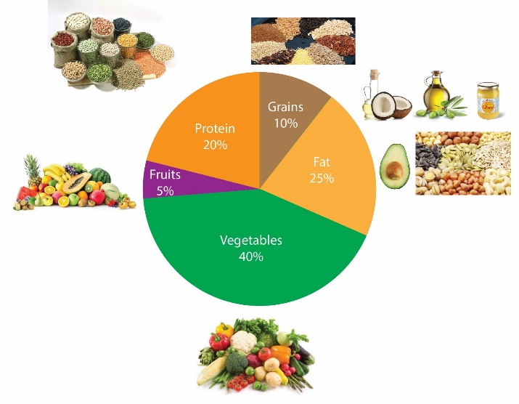

***BALANCED LIFESTYLE*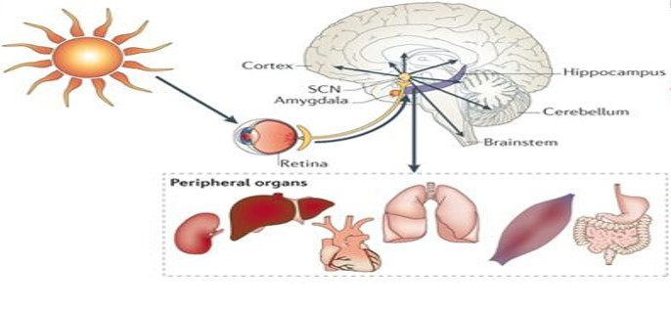**

**Radha Sukhani, M.D.**

**Chicago, IL USA**

**Understand the New Science of Obesity for a Permanent Natural Cure**

Copyright © 2019 by Radha Sukhani.  
All rights reserved. This book or any portion thereof may not be reproduced or used in any manner whatsoever without the express written permission of the publisher/author except for the use of brief quotations in a book review.

Printed and bound in India  
First printed February 2019

**Why Did Medical Doctors Not Treat Obesity?**

The industrial, economic, and current digital revolution, has brought a drastic change in the food and lifestyle of the population. The result is a global epidemic of obesity, its twin epidemic Type2 diabetes and related diseases - heart disease, high blood pressure, cancer, and more. Since it was a rare problem in the world until the 1970s; obesity did not get listed as a disease by the medical profession. Therefore, western doctors could not get paid to treat obesity. By default, management of obesity ended up with non-physicians such as dieticians, nutritionists and exercise trainers. Their common sense wisdom was that obesity occurs from eating more and moving less, and has to be treated by low-calorie diets and intense exercise plans. Over past 40 years, this scientifically untested theory of “caloric Imbalance” has been used in managing obesity with disappointing results.

**New Science: Obesity Is a Disease of Hormonal Imbalance and Not of Calorie Imbalance**

For the past almost 40 years, the caloric imbalance theory has dominated the commercial market of obesity management. Several varieties of “Low-calorie diet plans” – high protein, low carbohydrate, low fat or high fat -Keto plans, have been tested and tried along with many types of exercise plans. Unfortunately, billions of dollars invested in these remedies have produced only disappointing short-term results in obesity control.

In the year 2013, after much debate, the American Medical Association ( AMA), finally declared obesity a disease calling it the most significant single threat of the century to the global public health. Labeling obesity, a medical condition encouraged quality physician participation and research into the cause of obesity. The recent scientific studies have proved beyond a reasonable doubt that obesity is not a disease of caloric imbalance, but a condition of an imbalance of three essential hormones:

1. Insulin ( glucose utilization hormone)
2. Cortisol ( Stress hormone)
3. Melatonin ( sleep hormone)

This hormonal imbalance occurs from unhealthy food and unbalanced lifestyle :

* A shift from the traditional mostly natural plant foods to commercial foods-- The commercial foods lack an appropriate balance of macro and micronutrients. That gets the body into a food-seeking behavior called “ Nutrient Deficiency Hunger.”
* Feeding (eating) period more extended than fasting period in a 24-hour day cycle-- The long eating cycle keeps glucose and insulin levels high in most of the 24 hour day. High glucose and insulin levels promote abnormal fat storage in the body.
* Eating into the late hours of the night-- during the day the body requires energy for activity. Insulin is the energy-producing hormone. To maximize energy production from glucose; the body remains highly sensitive to insulin during the day hours. At night, the body is in a resting and repair mode, so insulin shifts gears, converting glucose into the reserve energy—the fat. Late-night eating, therefore, is a significant cause of fat storage and obesity.
* Frequent eating every 2-3 hours-- A meal of any size provides glucose for energy from the digestive tract for 2-3 hour. After this time the body falls back on the fat reserves for energy. Ideally, there should be a separation of 12 hours between the dinner and next morning meal, and 5-7 hours between any two subsequent meals of the day. This time separation allows the body to use up the stored fat energy between the meals. Eating every 2-3hours creates a constant glucose supply coming from the digestive tract. That takes away the great benefit of using up stored fat energy. The 2-3 hour diet plans, therefore, have failed to produce a permanent weight loss.
* Disruption of the Sleep-Wake cycle-Lack of exposure to morning sunlight or bright daylight reduces melatonin synthesis in the brain. Additionally, exposure to bright artificial light and blue light from the digital appliances at night reduces the secretion of melatonin. Less melatonin at night means disrupted rejuvenating deep sleep. Lack of sleep raises stress hormone cortisol levels. High Cortisol increases blood glucose and insulin levels, leading to fat storage. Lack of sleep by 1-2 hours/day has been shown to cause a weight gain of up to 10-15 kg.
* Immobility and Inactivity-Automobile use, desk jobs, and the sedentary lifestyle of the affluent population reduce the glucose consumption by muscles. Typically, muscles use up to 70-80% of glucose in the body. Less muscle activity means, more glucose available for making fat.

**The Concept of Good Health: Old Versus New**

Health and weight experts until recently linked good health to only two parameters: a) What we should eat, and b) How much we should exercise.

The new medical knowledge has linked good health to not just these two but in addition many other critically essential parameters: a) When we should eat, b) How often we should eat, c) When we should sleep and wake up, and finally, e) when we should exercise for maximum health benefit. All these critically important parameters are under the control of Brain’s circadian clock.

**The Critical Role of “Circadian Biologic Brain Clock” in Health and Disease**

 *“There are all kinds of lights for sight; but*

*For health, there is only the SUNLIGHT.”*

The research into the circadian physiology; its critical role in health and disease earned three medical physiologists- Drs Hill, Rosbash and Young, a Nobel Prize in October 2017. Understanding the function of the circadian brain clock and living in harmony with it, brings a healthy balance to the lifestyle. The combination of a balanced lifestyle and healthy holistic foods is the key to curing obesity and related diseases like Metabolic syndrome, PCOS in females, Type2 diabetes, high blood pressure, and heart disease.

**What is Circadian Brain Clock** - To adapt to daily changes in the dark and light cycles of the environment, all the living organisms, including the plants have developed an internal timing system. The circadian word comes from Circa—means circle or round, and Dian-means day.

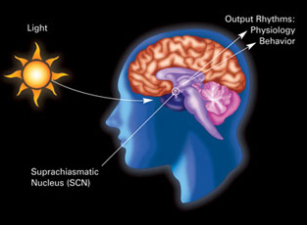

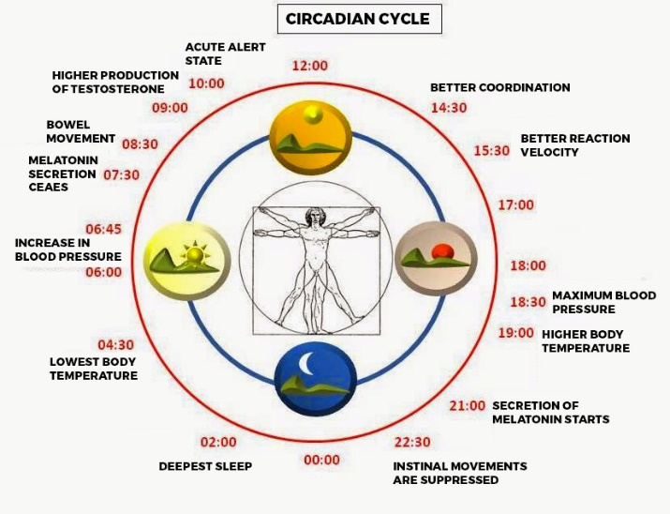

The Brain clock cycling system synchronizes to the light and the dark cues of the 24- hour day cycle. It controls all the physiologic functions in the body via the peripheral clocks located in all the body organs. Each organ system functions at its peak during the daylight hours; rests, repairs, and rejuvenates during night hours. The circadian clock synchrony is critical to the health and normal functioning of the digestive system, metabolism, hormonal balance, genes and rejuvenation of damaged cells.

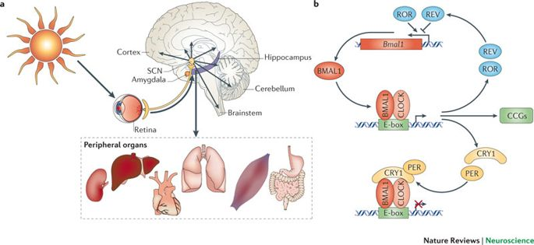

Living in harmony with brain clock is living with natural cues of light and darkness concerning:

1. Fasting- Feeding cycle
2. Sleep-Wake cycle
3. Exercise-Activity cycle.

**Human Circadian Rhythm: Fasting-Feeding Cycle**

Digestion, assimilation, and metabolism of the food are at its best only during the daylight hours. Artificial light has extended the day of a modern human beyond the typical daylight hours. The feeding times have become long, extending to the late-night hours. The average modern human eats multiple times over 14-15 hours in a 24- hour day.

Before 1970, the populations around the globe ate only three meals a day. These were consumed within 10-12 hours of the daylight. There was no global epidemic of obesity and related diseases in the world up until 1970. This epidemic relates to lack of attention to ***“what, when, and how often to eat.”***

**“When we eat and how often we eat is critical to preventing obesity and metabolic diseases.”**

A groundbreaking experiment on mice in 2009, by Dr. Panda and associates at Salk Institute in California, gave us a revolutionary insight to the effect of the timing and frequency of eating on the body weight and health. Two groups of mice born of the same parents were fed a similar amount of the same kind of food. One group was given free access to this food for all 24 hours of the day. The second group was assigned access to food only for 8 hours at the usual night time eating hours of the mice. After six weeks, the mice who ate all day long became obese. These mice also developed all the signs of the metabolic disease- high blood sugar, high-fat levels, and a fatty liver. The mice who had access to food only during their regular night eating time of 8 hours remained normal in weight and health. More interesting was the fact that excessive weight gain and metabolic disease reversed when the obese mice were put back on their usual time-restricted eating schedule.

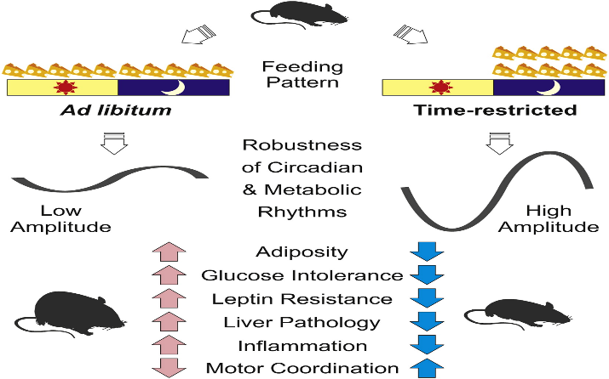

***“The time-restricted eating within the natural eating hours (in humans daylight) prevents and cures obesity, and its associated metabolic disease- high blood sugar, high blood fats, and fatty liver.”***

**Human Circadian Rhythm: Sleep-Wake Cycle**

Melatonin is the hormone of deep rejuvenating sleep. It is synthesized in the morning in the brain on exposure to sunlight or bright morning light. Melatonin gets stored in the Pineal gland of the brain. It gets released after the darkness of the night sets in. Inadequate exposure to morning light reduces the synthesis of melatonin.

Additionally, the release of melatonin at night gets inhibited on exposure to blue light from digital devices such as television, computer, and cell phone screens. Lack of deep rejuvenating sleep from melatonin imbalance increases stress hormone cortisol levels. High cortisol leads to obesity and diabetes. Several scientific studies have shown that lack of sleep even by 1-2 hours/ day, can cause a weight gain of as much as 10-15 Kg over a few weeks.

**Human Circadian Rhythm: Hormonal Balance**

The hormones in the body rise and fall with the circadian rhythms of the brain clock. The release and function of several essential hormones are under the control of the Sleep-Wake cycle of the circadian clock. These hormones are:

* Insulin ( glucose utilization hormone)
* Cortisol ( Stress hormone)
* Thyroid hormone ( energy balance)
* Growth hormone ( muscle growth and cell repair) -Deep rejuvenating sleep is critical to the optimal level of growth hormone in the body. The growing children who need more growth hormone get profound, deep sleep.
* Melatonin (sleep hormone).

Unbalanced lifestyle from a lack of synchrony with the circadian brain clock, produces hormonal imbalance diseases such as- Hypothyroidism, Insomnia, Metabolic syndrome including PCOS( Polycystic ovarian syndrome in females), Obesity, Type2 diabetes, high blood pressure, Heart disease.

**Human Circadian Rhythm: Activity and Exercise**

An active lifestyle and exercise are as essential as holistic food and rejuvenating sleep for the preservation of health and prevention of disease. Exercise and activity maintain a lean body, muscle and bone strength, digestion, heart and lung health, good sleep, good mood, and happy Spirit.

The body is most physically active in the morning hours. Muscle coordination is best in the late afternoon and early evening hours. For optimal health effect, the exercise timings are:

* Aerobic Exercise-These exercises increase the heart rate and are ideal for the morning or late afternoon or early evening.
* Strength or weight training—In the late afternoon and early evening hours when the muscle coordination is at its best. That is the time when competitive sports games get scheduled and played globally.
* Stretching exercises and Walking—Yoga, Tai-chi and walking are the ideal exercises for the mornings on an empty stomach. Early morning brisk walk for 20-30 mins has an additional advantage of bright sunlight or daylight exposure for maximum melatonin and vitamin D synthesis. The morning exercise on an empty stomach lets the body burn the stored fat energy. The “Dawn Phenomenon” in the body keeps glucose levels good in the morning for meeting the energy needs of the exercise.

**What is Dawn Phenomenon** - When the brain wakes up in the morning, the whole body function is in a high-performance manner. If there is not enough glucose in the blood to match the body’s morning activity needs; several hormones such as cortisol, glucagon, and adrenalin get released. These hormones work together to mobilize glucose from glycogen stores in the liver and muscles. It is because of the Dawn phenomenon that most people do not feel starved in the morning despite extended overnight fasting. Exercise also releases adrenalin, which speeds up glucose release from muscle glycogen stores.

**Obesity Epidemic of India**-Obesity is a fast-growing epidemic in urban India affecting both adults and children. The current prevalence of obesity is Females-35-%, Males-28.5%, Abdominal obesity (increased waist circumference)- 41 %.

The grades of severity of obesity are:

* Overweight-Body weight increase over 20% of the ideal body weight.
* Obesity-- Body weight increase to 50% over the ideal body weight.
* Morbid obesity- An increase to twice the ideal body weight.

A simple formula for ideal body weight calculation in Kilogram is:

Males= Height in centimeters--100

Females=Height in centimeters—105

Abdominal obesity (wide waistline at the navel level)--This carries a much higher risk for Type2 diabetes, high blood pressure, and heart disease.



**Incorrect Fat Theory of the 1970s**

Medical progress following the second world war successfully conquered the epidemics of infectious diseases such as cholera, smallpox, polio, plague, etc. The population started living longer. The longer living affluent people began suffering from the new medical condition -the heart disease. The medical doctors promptly recognized that the patients suffering from heart disease had higher levels of cholesterol and unhealthy fats in the blood. Common sense thinking was that dietary fat is the problem. Unfortunately, not taken into consideration was the fact that the diets were getting synthetic consisting of refined cooking oils, sugars, animal fats, refined wheat flour products, and the lifestyles were getting unbalanced.

The “Fat theory” that all fat is harmful became universally accepted. However, this theory has failed because humans need a standard amount of calories for survival. The lost fat calories in the diets got replaced by the readily available cheap carbohydrate calories. Within ten years of adopting the Fat Theory, two new global epidemics emerged -Obesity and Type2 diabetes. Both outbreaks are the gift ofthe low-fat theory of 1970 which did not take into consideration, a significant fact that there are healthy plant fats and also unhealthy animal fats. Healthy plant fats such as – Nuts, seeds, cold compressed vegetable oils such as mustard oil, sesame oil, coconut oil, and pure olive oil are healthy and a must in a balanced, holistic meal.

**Why Eating Healthy Fat is Essential for Health** Healthy fat was an integral part of traditional Indian meal up until the 1970s. For generations, our ancestors cooked food with ghee and cold compressed filtered oils such as – coconut, mustard, sesame, and peanut oil. Additionally, there was the tradition of eating only 2 or 3 meals per day during daylight hours. The Obesity and its twin disease Type2 diabetes were rare. The fat delays stomach emptying, which creates a feeling of fullness and satiation. That cuts down hunger as well as an appetite for the amount of food consumed at each meal. Healthy fat helps in prolonging time duration between two meals and makes 2-3 meal per day eating routine comfortable and possible. Although the low-fat theory has been discarded by medical science for almost a decade; the concept of the low- fat diet still dominates the public opinion. That thinking must change to reverse the course on the twin epidemics of obesity, Type2 diabetes, and related diseases.

**What Is Driving the Epidemic of Obesity**

There are three primary reasons for the fast-growing epidemic of obesity:

1. **Loss of traditional food culture from natural plant-based foods to commercially prepared synthetic junk foods**

Traditional societies eating traditional diets do not become obese. Japanese, Korean and Vietnamese population who stay lean in their countries become obese when they migrate to the west. That is because they adopt western ways of eating and lifestyles- refined synthetic sugary foods and beverages, multiple eating opportunities going late into night and immobility. That is also the typical story of an urban Indian.

1. **Adherence to the discredited low-fat theory of the 1970s**

It is time to discard the low-fat approach, and consume moderate amounts ( 30-50 gms- 7 to 10 teaspoons) healthy fats such as ghee and cold compressed vegetable oils. This simple change will eliminate the habit of eating multiple meals and will bring us back to the robust ancestral tradition of consuming 2-3 meals per day during the daylight hours.

1. **Incorrect knowledge of managing obesity**

Several billion dollars are spent year after year on the failed “Calorie imbalance theory” of low-calorie diets and intense exercise plans. The “Hormonal imbalance theory” based on research must be adopted to prevent and cure obesity via food and lifestyle change. Since insulin is the most critical hormone which gets into imbalance because of unhealthy diet and unbalanced lifestyle; one has to know more about it.

**What Is Insulin & Insulin Resistance (Imbalance)**

Insulin is an essential hormone for making energy from glucose. A human cannot survive without insulin for more than a few days. The pancreas gland secrets insulin when the food reaches the stomach. Insulin produces two types of energy from glucose :

* Immediate energy – The body cells need a constant source of glucose fuel to survive. Insulin is the glucose utilization hormone. It attaches itself to the cell receptor as a key fits in the lock. That opens the cell gate to accept glucose from the blood. With the help of oxygen and several micronutrients, glucose is broken down to make energy.
* Reserve energy for long-term use-Excessive glucose in the blood is converted to two reserve energy sources by insulin:

1. Glycogen energy reserve- Glycogen is a short-term energy reserve which is broken down rapidly into glucose. Food provides glucose for 2-3 hours worth of energy. Glycogen stores offer glucose fuel for energy between the meal times, especially during the long night-time fasting hours. The glycogen gets stored in the liver and muscles, and these hold up 24-36 hours of readily available reserve glucose energy.
2. Fat energy reserve—Fat is a long-time energy reserve which can provide energy to the body during long periods of starvation. The fat energy reserve represents the survival mechanism of humans. It evolved before the agrarian revolution when humans did not have a consistent supply of food for sustenance. Humans have an unlimited capacity to store fat as reserve energy made from glucose excess. Sugary foods, drinks, and unhealthy lifestyles of modern human are the leading causes of the obesity epidemic. Contrary to popular belief, it is the excess of glucose (and not fat) in the food which causes obesity.

**How does insulin resistance (imbalance) occur** High blood glucose from consuming high glycemic foods (refined sugar and refined flour food products, sugary beverages) increase the demand for Insulin from the pancreas beta cells? An increase in the blood level of insulin means more glucose gets forced into the cells. Since glucose excess is damaging, the cells protect themselves by blocking the insulin key, so the glucose cannot get in. This phenomenon of the inability of insulin to work usually to put glucose in cells is called “Insulin Resistance.” Excess unused glucose in the blood gets converted into the fat reserve energy by the insulin. In essence, insulin becomes a fat-storage hormone when there is an excess of glucose in the body. Fat storage due to insulin resistance is the root cause of obesity and Type2 diabetes.

**Insulin Resistance**

**Signs and Symptoms of Insulin Resistance**

Insulin resistance precedes obesity and Type2 diabetes. The insulin resistance identified early and managed effectively, will prevent both obesity and Type2 diabetes as well as heart disease high blood pressure. The signs and symptoms are:

* Lack of vigor and vitality- This occurs because insulin resistance prevents the body cells from getting usual amounts of glucose for producing energy.
* Excessive appetite and food cravings- These occur because insulin resistance keeps the body cells in a starvation mode. That leads to food cravings and urgency to eat.
* Abdominal obesity- Wider than average waist circumference indicates fatty liver and abdominal fat resulting from high glucose levels and Insulin resistance in the body.
* High levels of fasting blood glucose.
* Fatty liver diagnosed by ultrasound.

**Insulin Resistance, Metabolic Syndrome and PCOS (Polycystic Ovarian Syndrome)**

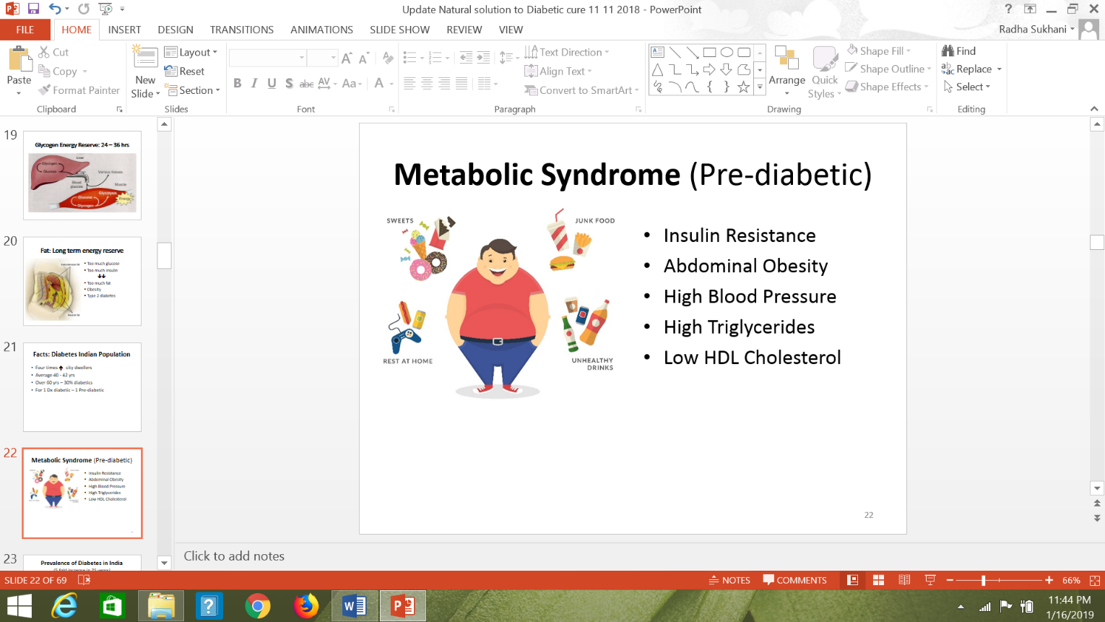Insulin resistance associated with obesity manifests as prediabetes conditions of Metabolic syndrome and PCOS. These prediabetic disorders affect young city dwellers of India in large numbers. Untreated these eventually lead to early Type2 diabetes, high blood pressure, and heart disease.

**Prevention and Cure of Obesity by Natural Means**

***“Insulin levels in the body hold the key to the prevention of obesity and Type 2 diabetes.”***

( Jason Fung M.D., *The Diabetes Code- Book)*

The plan is to manage hormonal imbalance by:

1. Adoption of holistic primarily plant foods.
2. Optimizing Fasting- Feeding periods in 24-hour day cycle- The feeding period should be limited to the daylight hours in harmony with circadian rhythms; when the digestive tract function and the insulin hormone sensitivity is at its best.
3. A rejuvenating deep Sleep and early wake-up time keep the harmony of circadian rhythm to normalize levels of several hormones --Insulin, Thyroid, Cortisol, Growth, and Melatonin.
4. Staying active and mobile during the entire daylight hours of the 24 hour day.

**Holistic Food Plate**



Basic rules of Holistic meal are as follows:

1. First and foremost eliminate two food poisons from the diet- Refined sugars and refined and milled wheat flours. That primarily includes – synthetic packaged foods, baked goods including bread, biscuits, cakes, muffins and all sugary beverages including fruit juices with no fiber. ***“Simply go back 50 years in our cultural tradition, when it comes to the cooking, eating and drinking.”***
2. Fruits--Eat one to two cups daily, preferably a mix of different fruits. Do not consume fruit as juices as juices are a concentrated form of fructose sugar with no fiber. An ideal time to eat fruits is in the morning and the worst time to eat fruits is at night-time after dinner. Fructose sugar in the fruits must get used up by physical activity-Unused fructose leads to fatty liver.
3. Vegetables-Four to five cups daily. Some of these should be eaten raw as salads. Eat a variety of vegetables of different colors to maximize on micronutrient intake.
4. Grains—Eat coarsely ground grains and avoid milled wheat and refined wheat flours. Always eat chapatis with healthy fat toppings such as butter or ghee, to minimize total grain consumption and postpone hunger. Make the upma and porridge from cracked wheat instead of refined semolina and instant oats. Stay with traditional breakfast options. Avoid the synthetic highly refined grain options such as boxed cereals and white bread which produce high blood glucose levels.
5. Seeds and nuts - Eat a fistful of mixed nuts daily such as peanuts, walnuts, almonds, pistachio, sunflower seeds, melon seeds, chia seeds, and sesame seeds. Seeds and nuts are a good source of protein and healthy omega-three oils.
6. Cold compressed oils and Ghee- Eat 40-50gm ( 7-10 teaspoonful ) of healthy fats daily to tame the appetite, postpone hunger and prevent overeating. Put ghee on chapatis and rice to slow the absorption of these grains from the digestive tract. Fat is the only macronutrient which does not require insulin for its utilization and does not raise insulin level. Avoid deep-frying as it converts healthy fats into trans-fats.
7. Lentils and legumes- Eat a variety in an amount up to one cup in a day.These contain both the protein as well as low glycemic carbohydrates.
8. Sprouts- The Sprouting process is our cultural tradition. Sprouted lentils and fenugreek seeds are a rich source of protein, fiber and vitamin B complex. The method of sprouting increases the protein content of germinated lentils by 30%.
9. Curds and yogurt- The fermented milk products sustain the growth of the good digestive bacteria. Compared to milk, fermented milk products are rich in lactase enzyme and well tolerated by the lactose intolerant Asian population.

**Balance Fasting - Feeding time in24-day Cycle**

A balance of Fasting-Feeding times in the 24-hour day cycle is critically important to the prevention and cure of obesity. Two essential aspects of this balance: a) When to eat, and b) How often to eat.Even the holistic food will lead to abnormal weight gain if meals are consumed frequently and into the late-night hours. A simple explanation is that the body’s circadian clock physiology is not set up to digest, assimilate and metabolize foods eaten frequently or into the late hours of the night.

“Time-restricted eating (TRE) within the 8-10 hours of daylight cycle is the most effective intervention for prevention and cure of obesity.” The food gets consumed at the time when the digestion, as well as metabolism are at their best.TRE plans offer many advantages:

* Improve Insulin sensitivity-During daylight hours the body is insulin sensitive and is in carbohydrate burning mode. During the night-time, the body is in the rest, repair, and fat storage mode.
* Improvement in the lipid profile—Lower levels of bad cholesterol and triglycerides. The extended nighttime fasting period uses up the stored fat in the body.
* Reversal of fatty liver—The liver is the first organ which gets rid of excess fat. Clearing of the fat from the liver improves insulin function with better utilization of glucose for energy rather than fat storage.
* Good sleep quality- Late night eating and poor sleep quality go hand in hand. For a deep rejuvenating sleep; the last meal of the day needs to be consumed at least 2-3 hours before the natural circadian sleep hour of 10-11 PM.

**Time-Restricted Eating (TRE) Plan for Weight Loss**

To have a lean and healthy body “when and how often to eat” is of utmost importance. The extended feeding cycle of 14-15 hours with last meal ending late at night leads to excessive fat storage and obesity. On the other hand, eating within a limited time window of the 8-10 hours during daylight hours improves insulin sensitivity with more glucose burning and less fat storage.

For the best results, an essential requirement of the TRE plan is a total commitment to a holistic mostly plant-based foods with moderate amounts of healthy fats: 40-50 gm (7-10 teaspoons). In addition to steady weight loss, the TRE plan eliminates liver fat, lowers blood glucose, bad cholesterol, and triglyceride levels.

**TRE Plan to maintain a healthy weight or treat mild obesity - 10-15kg over ideal weight**

Fasting –Feeding plan of 12:12 or 14:10 hours—This plan requires a three-meal schedule of breakfast, lunch, and dinner. Fasting period begins with dinner the previous evening between 7-8 PM and ends at breakfast the following morning between 8-10 AM. There should be 4-5 hours gap between breakfast and lunch; 6-7 hours gap between lunch and dinner.

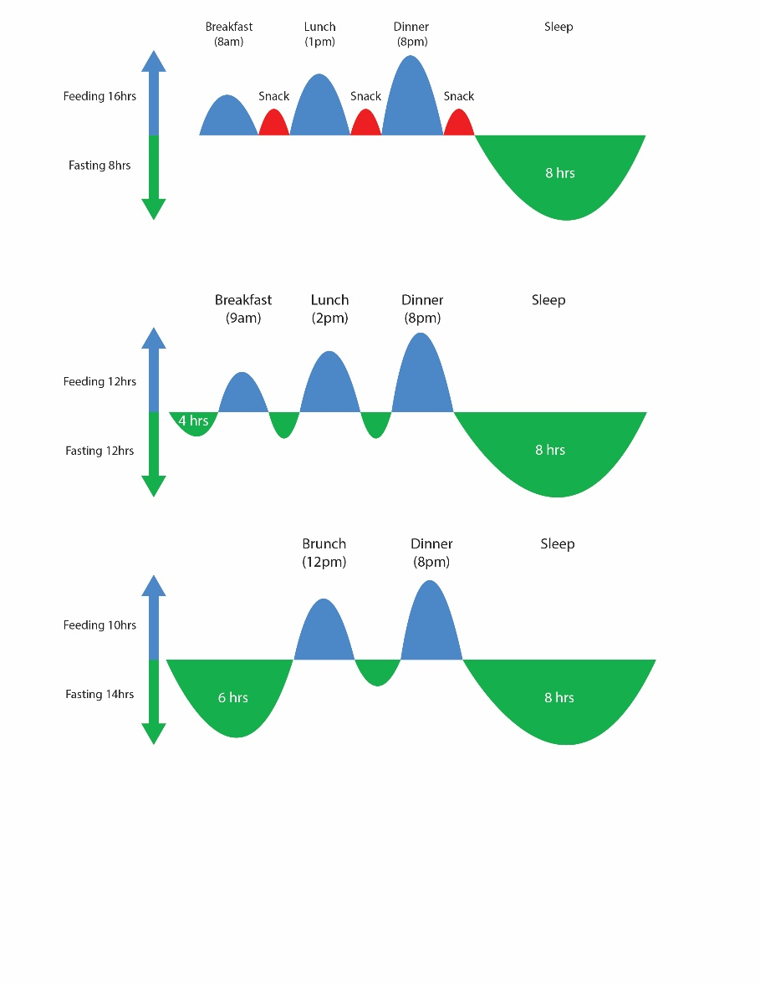

Breakfast

(8-9am)

**TRE Plan to manage abdominal obesity and moderate obesity 15-25 kg over ideal weight**

Lunch

(12nn)

Dinner

(8pm)

Fasting-Feeding plan of 16:8 hours—This plan requires a two-meal schedule of brunch (breakfast plus lunch as one meal) and dinner. Fasting period begins with dinner at 7-8 PM the previous evening and ends with brunch the following morning between 11 AM-12 Noon. The longer fasting cycle allows the body to use up stored fat reserve energy. The time duration between brunch and dinner is 7-8hours. If hungry between meals, one can have a healthy snack- a fistful of nuts or fruit with nuts.

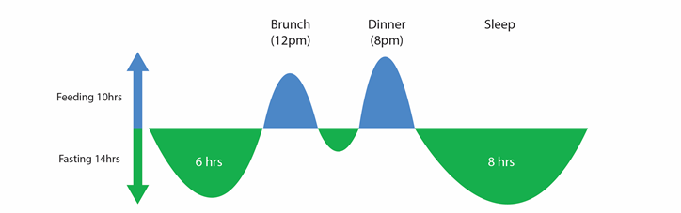

Feeding 8hrs

Fasting 16hrs

**TRE Plan to manage severe obesity -- weight greater than 25 kg over ideal body weight**

Fasting- Feeding plan of 18:6 hours- This plan also requires two meal schedule of lunch and dinner, skipping the breakfast. If breakfast is a preference, then one can skip dinner and adopt two meal plan of breakfast between 8-9 AM and late lunch between 2-4 PM. Prolonging fasting allows the body to consume more of the stored fat energy.

**TRE Plan of 24 hours fast with one meal per day** Those who are motivated to lose weight fast or those who are morbidly obese (twice the ideal body weight) can follow the 24-hour fasting with one meal in 24 hour day once or twice a week. This plan will be easy to add for those who are already well adjusted to the 18:6 or 16: 8-hour TRE plan.

**Advantages: TRE Plan over Low-Calorie Diet Plans:**

1. In contrast to diet plans which are limited in time to weeks or few months, TRE plan can become a way of life. Once the desired weight goal is met, the program is scaled back to an easy basic 12: 12-hour plan.
2. TRE plan is more manageable than “Low-Calorie Diets” because most fasting period is during the night-time sleep hours.
3. The inclusion of healthy fats and no-calorie restriction in TRE plan; ensures satiation with no food cravings, which are a common problem with low-calorie diets plans.
4. There is no micronutrient deficiency or muscle loss since there is no restriction on the amount of holistic meal consumed at mealtimes.

**Mobility/Activity and Exercise:** Keeping active and mobile the entire day keeps metabolic rate in high gear for the whole day. Intermittent aerobic exercise 2-3 days/week, on the other hand, create highs and lows in metabolism. The ideal program for keeping active the entire day is: start the day with yoga and pranayama, 20-30 minutes of a brisk walk or climbing stairs, 7-10,000 steps a day. Key is keeping active and moving the entire day.

**Conclusions:** The industrial, economic, and current digital revolution has brought a drastic change in the food and lifestyle of the global population. The result is an epidemic of obesity with its related diseases- Type2 diabetes, High Blood pressure, Heart disease, cancer and many more. The treatment of obesity by expensive “Diets and Exercise plans” has failed over the past 40 years. The research supports that obesity is a disease of hormonal imbalance involving Insulin, Cortisol, and Melatonin. The imbalance results from:

* Unholistic synthetic and junk foods rich in refined sugars and refined wheat flour, which increase blood sugar and demand for Insulin leading to insulin resistance. That is the dysfunction which leads to fat storage.
* Unbalanced lifestyles not lived in harmony with the natural rhythms of circadian brain clock concerning Fasting- Feeding, Sleep-wake, and activity cycles. That disrupts the Digestive, Metabolic, Hormonal, and Genetic functions.

**“ Holistic Plant-based foods and Circadian rhythm harmony lived with natural cues of light and darkness are essential to the preservation of health and prevention of disease. Nature and the sunlight nurture body and hold the key to our good health”**

