**Manage & Reverse Type2 Diabetes by Food and Lifestyle Change**



Car photo from Dreamstime.com

**I’m in charge**

**Not my diabetic drugs!!**

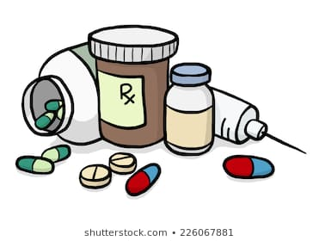

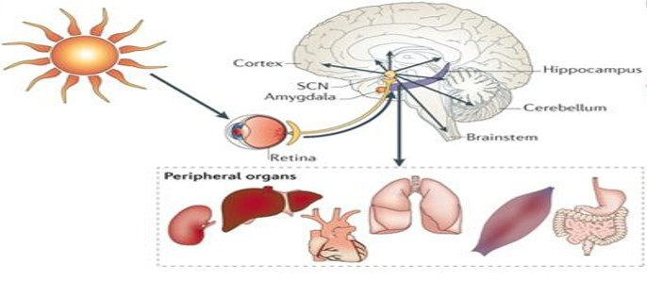

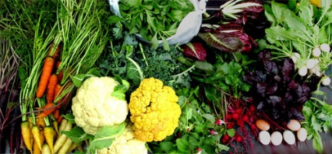

**Radha Sukhani, M.D.**

**Chicago, IL USA**

Copyright © 2019 by Radha Sukhani.  
All rights reserved. This book or any portion thereof may not be reproduced or used in any manner whatsoever without the express written permission of the publisher/author except for the use of brief quotations in a book review.

Printed and bound in India  
First printed February 2019

**Manage & Reverse Type2 Diabetes   
by Food and Lifestyle Change**

**Background** - Medical profession has labeled Type 2 diabetes a progressive, lifelong disease with no hope for a cure. The treatments offered in allopathic medicine are symptomatic, focused primarily on lowering the blood sugar (glucose) levels. The list of antidiabetic drugs keeps growing with each succeeding year, none offering prevention or a cure. The unfortunate diabetic patients on multiple medications, continue to deteriorate over time, remaining dependent on the expensive treatments for the remainder of their living lives. The age-old wisdom in medicine states:

*“In medicine, we ought to know the cause of the disease to be able to find an effective cure.”* - Avicenna, the Persian Physician (980-1037)

The cause of Type2 diabetes is unhealthy, commercial foods, an unbalanced lifestyle, which causes a build-up of glucose in the body. The logical solution to prevention and cure, therefore, should be a modification of the Food and Lifestyle to minimize blood glucose levels. The anti-diabetic drugs including insulin injections do not remove the excess glucose from the body. These medications merely rearrange the glucose out of the blood and force it into the body cells. The excess glucose pushed into the cells is the cause of complications such as Retinopathy- eye damage, Heart disease, Neuropathy- nerve damage, Nephropathy- kidney damage, stroke, limb damage, etc.

Food and Lifestyle, are entirely under the control of the patient, who can take charge of how much glucose gets into the body. Logically, therefore, the patient should be in the driver’s seat, when it comes to managing diabetes and controlling the antidiabetic drugs dosages. The episodes of hypoglycemia which occur from antidiabetic medications should be the cue that too much medicine is in the body, and the dose must be decreased. The hypoglycemic episode should not be a routine quick fix of sugary snack or sweet beverages. That keeps putting more glucose in the body, making the disease worse.

**Urban India: Diabetes Capital of the World**

Type2 Diabetes is currently a global epidemic with India and China in the lead. The incidence of Type2 Diabetes in China before 1980 was less than1% and in India less than 5%. Currently, Type 2 diabetes affects 12-14% of the population. Over the age of 60 years, every third urban Indian has diabetes, and for each one diagnosed diabetic, there is one more who suffers from a pre-diabetic condition called metabolic syndrome. The average age of onset of Type2 diabetes in India currently is 32-35 years. Type2 diabetes runs in families, not only because of diabetes genes but also because families have similar food and lifestyle habits.

Type 2 diabetes and Obesity are twin diseases which share a similar cause – unhealthy foods and unbalanced lifestyle. About 80% of the patients who have diabetes are obese, and 20% who are not, have large waist circumference (abdominal obesity). Major culprits contributing to the twin epidemic of obesity and Type2 diabetes in urban India are:

* Refined sugars and refined wheat flour food products and beverages.



* Frequent eating opportunities (6-7 time) in a day-That keeps blood glucose high most of the day, creating a higher demand for the hormone Insulin. High Insulin levels cause Insulin resistance (imbalance). That is at the root of both obesity and Type2 diabetes.
* Late-night eating- Body is insulin sensitive during the daylight hours and Insulin resistant at night. Insulin sensitivity keeps the body in a carbohydrate (glucose) burning mode, while the insulin resistance shifts the body metabolism into fat storage mode. Insulin resistance is the reason why night shift workers (who eat late at night and skip natural sleep hours) develop medical problems such as Obesity, Metabolic syndrome (prediabetes), Type2 diabetes and Heart disease. The late-night eaters in this respect are not different from a night shift worker. Even when healthy; the meals at late night hour will lead to obesity.

**The Role of the Circadian Brain Clock in Health and Disease**

|  |
| --- |
| Illustration of a human brain with the suprachiasmatic nucleus labelled. |

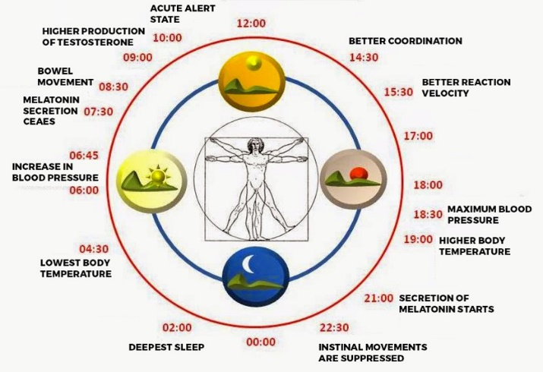

The living organisms, including plants, have developed an internal circadian timing system to adapt to daily environmental changes of light and darkness. Circa-means circle, and dian- means the day. The circadian timing system in humans is a central brain clock (specialized nerve cells). It is located in the brain just behind the center of the forehead between the eye sockets. This brain clock synchronizes various body functions to the cues of light and dark cycles of the day. In addition to the central brain clock, there are peripheral clocks located in all the body organs-- digestive tract, liver, heart, kidneys, thyroid gland, adrenal glands, etc. In coordination with the brain clock, the peripheral clocks set up the peak activity time of the organs at a particular time of the day and then rest and rejuvenate at the other times of the day.  
 The life not lived in harmony with the central brain clock to the cues of light and darkness adversely affects physiological functions such as:

1. The hormonal balance- Exposure to morning sun or bright daylight controls the release and function of many essential hormones such as Insulin, Cortisol, Thyroid, Growth, and Melatonin (sleep hormone).
2. The digestive balance-The digestive system is in high activity mode during the daylight, and in a dormant resting and repair mode during the dark period of the night. The intestinal activity slows down by 10 PM.
3. Liver function and metabolism-These are in a carbohydrate burning mode during the day and in a fat storage mode at night. The glucose absorbed from the food consumed late at night will get stored as fat.
4. Genetic balance-The lifestyle not lived in harmony with central brain clock changes the gene proteins called gene mutation, which leads to diseases. The fast-growing modern epidemics of Type2 diabetes, obesity are considered an epigenetic phenomenon from such gene mutations.
5. Sleep balance—Eating and sleeping late at night, disrupts deep rejuvenating sleep. Additionally, waking up late reduces exposure to bright morning light; critical to the synthesis of the sleep hormone melatonin. Lack of deep sleep leads to weight gain and glucose imbalance from an excess of the stress hormone cortisol.

To summarize, living in harmony with circadian rhythms is the secret to living in good health, allowing body time for rest and repair. The groundbreaking research into circadian physiology and its role in health and disease earned a Nobel Prize in 2017, to three medical physiologists – Drs. Hill, Rosbash, and Young.

**Type 2 Diabetes starts with Insulin excess and fat storage in the body** -Consuming foods rich in refined sugars and refined wheat flour cause high blood glucose levels which increase the demand for Insulin -the glucose utilization hormone. Insulin is responsible for creating two types of energy:

1. The energy used immediately by the cells.
2. The reserve energy- The glucose from food meets energy needs only for 2-3 hours following a meal. After this time, the body relies on the glucose released from the two kinds of reserve energy sources:

* Glycogen reserve energy stored in liver and muscles- This constitutes short-term reserve energy. Muscles carry 18-36 hour worth, and liver 12-18 hour worth of glucose reserve as glycogen.
* Fat reserve energy – Fat stored in the liver, muscles, and rest of the body constitutes long-term energy reserve good for 3-4 weeks. The fat storage mechanism of humans evolved because pre-agrarian humans did not have a consistent supply of food. The modern affluent humans, on the other hand, has easy access to sugary foods and drinks. The excess of glucose in the body gets converted to fat, with no limit on weight gain. Only extended fasting can use up the fat reserve in the body.

**Understanding Type2 Diabetes**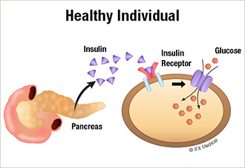-Type 2 Diabetes starts as a disease of glucose and insulin excess in the body. The culprits being highly refined sugary foods/ beverages, and refined wheat flour products (high glycemic foods). High Insulin levels lead to a phenomenon called Insulin resistance. That means Insulin cannot do its regular work of transporting glucose into the cells for making energy.

|  |
| --- |
|  |
|  |

**What is Insulin Resistance?** Insulin works like a key which opens the lock on the receptor gate for glucose to enter the cell. When the blood glucose level goes abnormally high, the cell receptor gate blocks the insulin key. That decreases glucose entry into the cells and saves the cells from the damage caused by an excess of glucose. The insulin resistance, therefore, protects the cells from glucose toxicity, but it has two undesirable effects:

1. Food cravings and overeating--Less than the usual amount of glucose entering the cells means, cells are starving for glucose. That causes food cravings/overeating; experienced commonly by patients who have diabetes and prediabetes condition -metabolic syndrome.
2. Excessive fat synthesis-Less glucose entering the cells means more glucose leftover in the blood to be converted into fat by the insulin.

**Two stages of Type2 Diabetes**

* The early stage of Insulin excess and Insulin resistance-The body cells cannot get the usual amount of glucose for making energy. That is a signal to pancreas gland to produce more insulin. Food and lifestyle modifications to reduce blood glucose at this stage will prevent insulin resistance.
* The late stage of Type2 Diabetes- As diabetes advances, fat gets deposited in the pancreas gland. The fat accumulation damages insulin-producing beta cells. At this stage, insulin injections are needed to control blood glucose. Food and lifestyle modifications to lower blood glucose at this stage will minimize Insulin, and antidiabetic drug need and a better blood glucose control. That reduces the risk of diabetic complications such as eye, kidney, heart, nerve and limb damage

**Cost of care of Diabetes**--Both Type1 or Type2 diabetes cause tremendous human suffering and disability. Allopathic medicine has not yet offered any cure. The cost of care of an uncomplicated diabetic is Rs15—30,000 per year and that of diabetic with complications (Eye, Heart, and Kidneys), several times higher.

**Type 2 diabetes and Fructose sugar connection-**Fructose is the sugar found in fruits, fruit juices, and high fructose corn syrup (HFCS). The HFCS is the leading sugar supplement used by the beverage and commercial food industry (sodas, colas, sports drinks, pre-prepared fast foods). Fructose sugar is uniquely different from regular white sugar. Unlike regular sugar, fructose does not increase blood glucose level and does not require insulin hormone for its utilization. After absorption from the digestive tract, fructose gets transported to the liver directly for use as an energy source. Fructose in excess gets converted to fat in the liver. The fatty liver is a leading cause of insulin resistance which starts the disease process of obesity and Type2 diabetes. Significant sources of fructose are:

1. Fruit juices - In comparison to the fiber-rich fruit, the fruit juices have no fiber and get consumed and absorbed rapidly. One glass of orange juice from 4 oranges is a hefty 30 gm of fructose; one can gulp in 90 seconds.
2. Regular white sugar is an equal mixture of glucose and fructose.
3. HFCS – The chemical sugar from corn gets widely used by the soda, sports drinks, and commercial food industry.

“ Fructose is in fact, the “hidden enemy” responsible for the fatty liver, and the global epidemics of obesity, metabolic syndrome, Type2 diabetes, high blood pressure, and heart disease.”

**Managing Type 2 diabetes: Must Become a Personal responsibility**

Food and lifestyle are entirely in the control of individuals; who are empowered with decisions regards to:

1. What to eat- Holistic primarily plant-based natural foods versus synthetic foods.
2. When to eat- Late night eating means consuming the food when the body is in the fat storage and not in a carbohydrate (glucose) burning mode.
3. How often to eat – Before 1970, most populations ate three meals a day with last meal ending within daylight hours. Typical night-time fasting and repair period was 12 or more hours. Globally, both Type2 diabetes and obesity were rare until 1970. The current city dwellers in a 24 hour day, have 5-6 eating opportunities between their meals and snacks. The feeding period of modern city dweller extends 14-15 hours running late into the night. This risky lifestyle of prolonged eating forces the body in an insulin-producing mode for several hours, leading to insulin resistance.
4. Sleep-Wake Cycle- A lifestyle of eating and sleeping late, disrupts deep sleep so critical to good health. Lack of sleep even by 1-2 hours/day raises the stress hormone cortisol, which causes 10-15 kg weight gain and increases the risk of Type 2 diabetes.
5. Mobility, Activity, and Exercise—Muscles use up to 80% of the glucose consumed. An active lifestyle means more glucose consumption and low blood glucose levels.

Finally, antidiabetic medications can not reverse or cure Type2 diabetes. New antidiabetic drugs keep flooding the market( more than 30 new drugs in the past ten years). These new drugs generate billions of dollars in profits for big pharmaceutical companies, but none will cure the disease. Type 2 diabetes is a food and lifestyle disease; therefore, fixing it must become a personal responsibility.

**Personal management strategy for Type2 diabetes**

**Aim -r**educe glucose level by food and lifestyle modification to minimize the antidiabetic drug requirements. The rules of self -managing diabetes:

1. Carefully monitor fasting and 2-hour post-meal blood glucose levels. Work in coordination with the medical doctor.
2. Eliminate all refined sugars and fructose sugars – Sugary beverages rich in HFCS, fruit juices, sweets, baked goods-bread, cakes, pastries, packaged, and commercial foods.
3. Eliminate food products made from refined wheat flour - baked goods, synthetic boxed foods, and packaged foods including biscuits, breakfast cereals, energy bars, etc.
4. Must consume 40-50gm (7-10 teaspoons) of healthy fats daily. Amongst the three macronutrients (carbohydrate, fat, and protein), fat is the only macronutrient which does not require insulin hormone for its utilization in the body. Healthy fat delays stomach emptying and curbs the appetite. Elimination of healthy fats from the diet in the past 40 years, is the most significant reason for the twin epidemics of obesity and Type2 diabetes. Healthy fats include ghee and cold compressed, unrefined filtered oils such as – Coconut oil, Mustard oil, Sesame oil, Peanut oil, and Flaxseed oil.
5. Eat a balance of 3 Macronutrients:

* Eat 50-60% of food calories as fiber-rich, low glycemic carbohydrates such as fruits, vegetables, lentils, and legumes.
* Eat 25-30 % of food calories as healthy fats- ghee, cold compressed filtered oils ( see above list) -30 to 50 gms (6-10 teaspoons) — a healthy fat amount higher in lean, and less in overweight diabetic.
* Eat 15-20% of foods as healthy, primarily plant-based proteins rich in fiber- lentils legumes, seeds, and nuts. The animal proteins including milk have zero fiber and are rich in saturated fats.

Holistic Meal Plate

|  |
| --- |
|  |

Eat a high fiber diet which lowers insulin requirement and insulin resistance. Fenugreek seeds (1-2 teaspoons) are beneficial to diabetics because of high fiber and trigonelline content which help in lowering blood sugar, cholesterol, and triglycerides.

1. 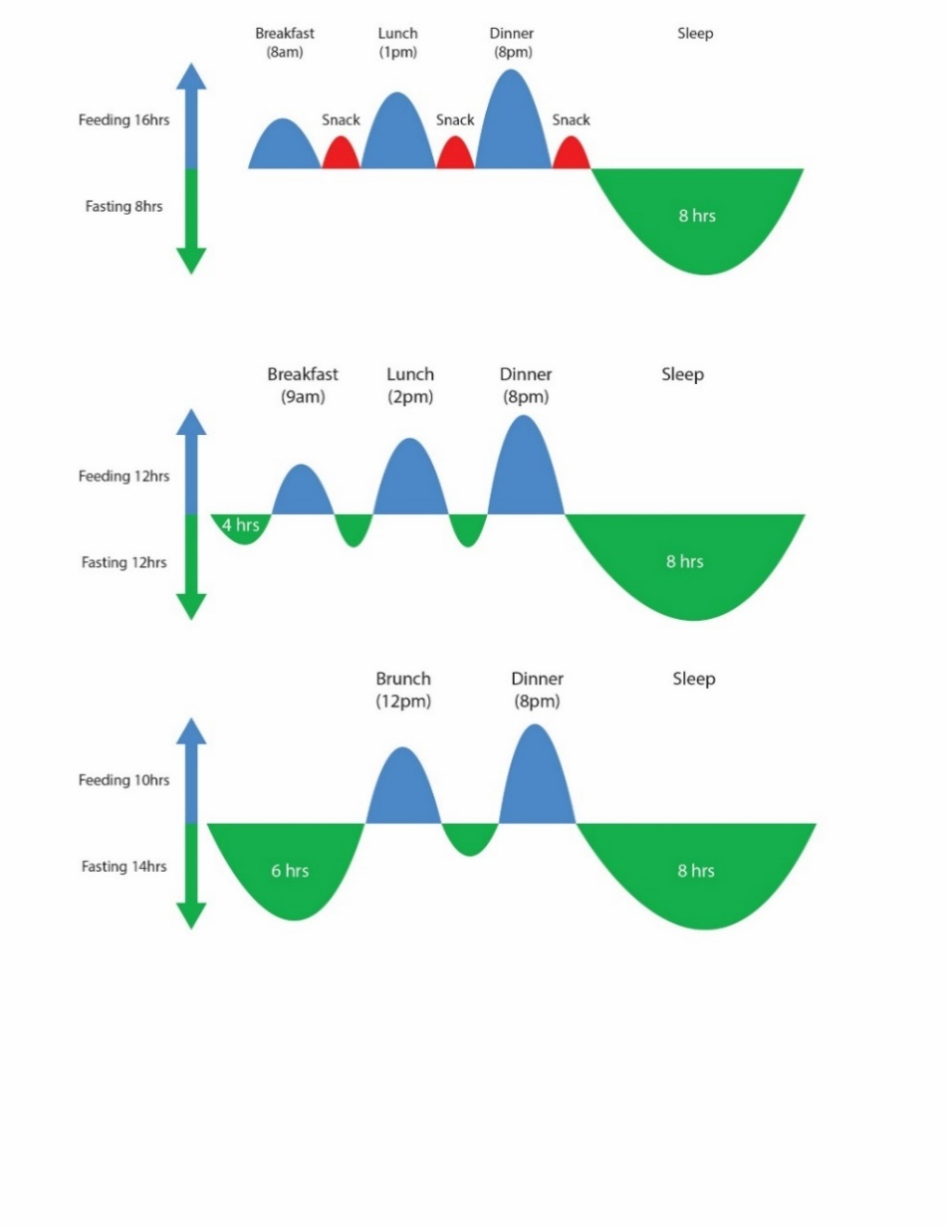Minimize eating opportunities, and stay with the old tradition of 2-3 meals per day, keep 5-7 hours between the daytime meals and 12 or more hours between dinner and breakfast. That keeps insulin levels low. Multiple eating opportunities with snacks between meals increase the risk of obesity and Type2 diabetes by prolonging feeding hours which keep insulin levels high.

|  |
| --- |
|  |

1. Live a balanced life in harmony with the rhythms of the circadian brain clock concerning Fasting- Feeding, Sleep-Wake, and activity cycles. The digestive system is active only during the daylight hours and slows down after 10 PM. The body is in the (glucose) burning mode during the active daylight hours. It is in the fat storage mode during the quiet, dark hours of the night. Regular Fasting – Feeding cycle works well in harmony with normal Sleep-wake cycle. “Late eaters, eat more and sleep poorly.”
2. Eat within the daylight hours, never eat after 8 PM. Even the most holistic food consumed late at night will lead to fat storage as the body is insulin resistant mode, unable to utilize glucose for energy.

An excellent example of circadian rhythm imbalance is the lifestyle of night shift workers, who eat and sleep at ungodly hours of the day. Within a few months of night shift work, these individuals develop obesity, Type2 diabetes, high blood pressure, and heart disease.

**Time-restricted eating (TRE) Plan for Type2 diabetes**- An essential requirement of TRE plan is a commitment to low glycemic predominately plant-based foods with moderate amounts-40-50 gm (8-10 teaspoons) of healthy fats. The fiber-rich plant foods and healthy fats together tame hunger and appetite. Time-restricted eating, along with holistic foods, keeps glucose and insulin levels low and stable. Based on the severity of disease and type of medications patient is taking, blood glucose initially may need to be checked 2-4 times a day. That is essential if the patient is on drugs which increase insulin levels and risk of hypoglycemia (Insulin injections, Sulfonylureas, and TZDs).

“Patients must keep dinner time before 8 PM.”

1. Start with TRE 12: 12-hour plan- Fasting period of 12 hours between dinner the previous evening and breakfast the next morning. The meal schedule consists of 3 meals – breakfast, lunch, and dinner with no snacks in between. Hypoglycemia requiring sugary snack is the signal that the antidiabetic medication dose should be reduced. The time gap between the day-time meals should be 5-7 hours.

|  |
| --- |
|  |

1. TRE 14:10 hour plan-Fasting period of 14 hours between dinner the previous evening and brunch (breakfast plus lunch) the following morning. The meal schedule should consist of 2 meals- brunch and dinner. If hungry between meals; can have a healthy low glycemic snack.

|  |
| --- |
|  |

1. TRE 16: 8-hour plan—Fasting period of 16 hours between dinner the previous evening and brunch the following morning — the meal schedule to consist of 2 meals- brunch and dinner, preferably no snack.

The fasting period at night should be advanced as tolerated in 1 -2-hour increments at every 1-2 week intervals. This plan will lead to slow and sustained weight loss with it a gradual reduction in the need for antidiabetic medications including Insulin dose. There is no restriction on the amount of holistic, low glycemic –plant-based carbohydrate foods consumed at each meal. Timely blood glucose monitoring is critical to plan success. Also essential is 40-50gm (7-10 teaspoons) healthy fats- ghee and cold compressed vegetable oils.

**Mobility/Activity and exercise**-Mobility and exercise are an essential requirement, as muscles consume 70-80% of the glucose absorbed from the food. The key is to keep active the entire day and not just the aerobic exercise 2-3 times a week. A simple and no cost routine to stay active all day is:

* Walking 7-10,000 steps over the 24-hour day (the equivalent of 3-4 miles/day).
* Climbing stairs (aerobic) -Take 2-3 flights of stairs daily or more as tolerated.
* Yoga- 30 minutes/ day to build muscle tone.
* Stand and move more than sitting to stay active and burn more calories.

**Conclusions:** Type 2 diabetes starts with high blood glucose. Two culprits responsible are refined sugar and refined wheat flour foods and all sugary beverages including fruit juices. High blood glucose increases the need for hormone insulin. Excess insulin in the body leads to Insulin resistance – an inability of insulin to work correctly for making energy. That starts the disease process of both obesity as well as Type2 diabetes. The following strategies minimize insulin need and insulin hormone resistance:

1. Eat mostly plant-based fiber-rich foods. Avoid synthetic commercially prepared foods and beverages rich in refined sugars and milled wheat flour. Eat fiber-rich fruits, not the juices which are concentrated fructose sugar and are a risk for fatty liver.
2. Eat 40-50 gm (7-10 teaspoons) of healthy fats- ghee and cold compressed filtered oils.
3. Live a balanced lifestyle in harmony with circadian rhythms of brain clock considering timings of Fasting- Feeding, Sleep-wake, and activity/Mobility in 24-hour day cycle:

* Keep the fasting duration longer than feeding duration in a 24-hour day cycle.
* Dinner time- Do not eat late and preferably conclude the dinner meal before 8 PM.
* The frequency of eating-- stay with the time-honored tradition of 2-3 meals per day with 12-16 hours between dinner and breakfast and 5-7 hours between day meals.
* Optimize the Sleep-Wake cycle for rejuvenating deep sleep.

1. Keep active and mobile for the entire day.

